CAS SciFinder Task History

January 3, 2025, 2:48 PM

Initiating Search

Reactions: | Structure Search  

Filtered By:
Structure Match: As Drawn
Substance Role: Reactant
Yield: 90-100%
Non-Participating Functional Groups: Ether, Alkene, Organometal, Cyclic alkene, Amine, Diene, Cyclopentadienyl metal, Tertiary amine, Carboxamidine, Amide, Imine, Alcohol, Ketone, Primary amine, Urea, Acetal, Acyclic alkene, Acyclic ketone, Carboxylic ester, Halide, Primary alcohol, Secondary amine, Nitrile, Carboxylic acid, Phenyl halide, Sulfide, Aldehyde, Alkyl halide, Alkyne, Cyclic alcohol, Cyclic ketone, Nitro, Secondary alcohol, Unsaturated ester, Phosphonate
Reaction Type: Full
Language: English
Publication Year: 2000 to 2024

Excluded:
Reaction Mapping: No Mapping Data Available
Solvent: THF-d₈, Acetonitrile-d₃, Benzene-d₆
Reaction Notes: Thermal, Microwave Irradiation, Ultrasound
CA Section: Electrochemical, Radiational, and Thermal Energy Technology, Magnetic Phenomena

Search Tasks

1. Exported: Returned Reaction Results + Filters (152) View Results

View in CAS SciFinder

Reactions (52)

1. Scheme 1 (1 Reaction)

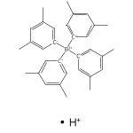  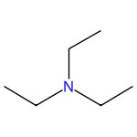 |  | 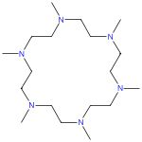 |  | 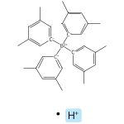

Cationic barium benzyl and hydride complexes that contain an eighteen-membered N,N,N,N,N,N-type macrocycle
By: Hoellerhage, Thomas; et al
Inorganica Chimica Acta (2022), 543, 121198.
Find It @ Emory
10.1016/j.ica.2022.121198
View All Sources in CAS SciFinder

Steps: 1, Yield: 97%
CAS Reaction Number: 31-614-CAS-34849067
1.1 | Solvents: Tetrahydrofuran; rt; 2 min, rt

2. Scheme 2 (1 Reaction)

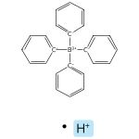 |  | 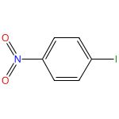 |  | 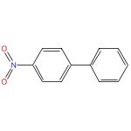

Preparation of Triethylammonium Tetra-Arylborates (TEATABs): Coupling Partners for the Suzuki Reaction
By: Kuuloja, Noora M.; et al
Synthetic Communications (2011), 41(7), 1052-1063.
Find It @ Emory
10.1080/00397911003718086
View All Sources in CAS SciFinder

Steps: 1, Yield: 98%
CAS Reaction Number: 31-177-CAS-12272858
1.1 | Reagents: Sodium carbonate
 | Catalysts: Palladium diacetate
 | Solvents: Acetone, Water; 10 h, 25 °C
1.2 | Reagents: Hydrochloric acid
 | Solvents: Water

3. Scheme 3 (1 Reaction)

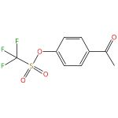 |  | 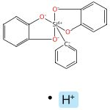 |  | 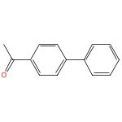

Preparation and Palladium-Catalyzed Cross-Coupling of Aryl Triethylammonium Bis(catechol) Silicates with Aryl Triflates
By: Seganish, W. Michael; et al
Journal of Organic Chemistry (2004), 69(4), 1137-1143.
Find It @ Emory
10.1021/jo035309q
View All Sources in CAS SciFinder

Steps: 1, Yield: 96%
CAS Reaction Number: 31-177-CAS-14507255
1.1 | Reagents: Tetrabutylammonium fluoride
 | Catalysts: Bis(dibenzylideneacetone)palladium, 2-(Dicyclohexylphosphino)biphenyl
 | Solvents: Tetrahydrofuran; 6 h, reflux

4. Scheme 4 (1 Reaction)

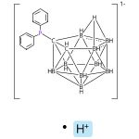  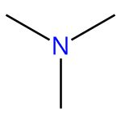 |  | 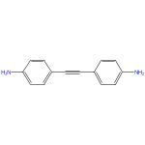 |  | 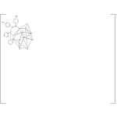

Couple-close construction of non-classical boron cluster-phosphonium conjugates
By: Sun, Zhaofeng; et al
Nature Communications (2024), 15(1), 7934.
Find It @ Emory
10.1038/s41467-024-51506-3
View All Sources in CAS SciFinder

Steps: 1, Yield: 95%
CAS Reaction Number: 31-614-CAS-41964304
1.1 | Catalysts: Palladium diacetate
 | Solvents: 1,2-Dichloroethane; 6 h, 35 °C

5. Scheme 5 (1 Reaction)

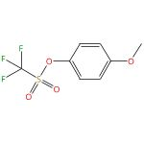 |  |  |  | 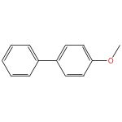

Preparation and Palladium-Catalyzed Cross-Coupling of Aryl Triethylammonium Bis(catechol) Silicates with Aryl Triflates
By: Seganish, W. Michael; et al
Journal of Organic Chemistry (2004), 69(4), 1137-1143.
Find It @ Emory
10.1021/jo035309q
View All Sources in CAS SciFinder

Steps: 1, Yield: 97%
CAS Reaction Number: 31-177-CAS-11056605
1.1 | Reagents: Tetrabutylammonium fluoride
 | Catalysts: Bis(dibenzylideneacetone)palladium, 2-(Dicyclohexylphosphino)biphenyl
 | Solvents: 1,4-Dioxane; reflux

6. Scheme 6 (1 Reaction)

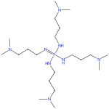 |  |  |  | 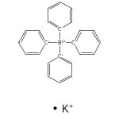

Basicity Enhancement by Multiple Intramolecular Hydrogen Bonding in Organic Superbase N,N’,N’’,N’’’-Tetrakis(3-(dimethylamino)propyl)triaminophosphazene
By: Ullrich, Sebastian; et al
Organic Letters (2019), 21(22), 9142-9146.
Find It @ Emory
10.1021/acs.orglett.9b03521
View All Sources in CAS SciFinder

Steps: 1, Yield: 98%
CAS Reaction Number: 31-575-CAS-20714248
1.1 | Reagents: Potassium tert-butoxide
 | Solvents: Tetrahydrofuran; 30 min, rt

7. Scheme 7 (1 Reaction)

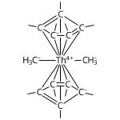 |  |  |  | 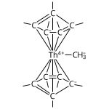  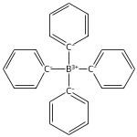

Synthesis, Structure, and Reactivity of the Sterically Crowded Th3+ Complex (C5Me5)3Th Including Formation of the Thorium Carbonyl, [(C5Me5)3Th(CO)][BPh4]
By: Langeslay, Ryan R.; et al
Journal of the American Chemical Society (2017), 139(9), 3387-3398.
Find It @ Emory
10.1021/jacs.6b10826
View All Sources in CAS SciFinder

Steps: 1, Yield: 95%
CAS Reaction Number: 31-614-CAS-27797426
1.1 | Solvents: Benzene; 2.5 h, rt

8. Scheme 8 (1 Reaction)

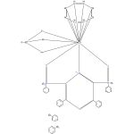 |  |  |  | 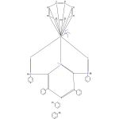

Organouranium Complexes with Phosphinine-Based SPS Pincer Ligands. Variations with the Substituent at the Phosphorus Atom
By: Arliguie, Therese; et al
Organometallics (2008), 27(16), 4158-4165.
Find It @ Emory
10.1021/om8003493
View All Sources in CAS SciFinder

Steps: 1, Yield: 94%
CAS Reaction Number: 31-562-CAS-5732312
1.1 | Solvents: Tetrahydrofuran; 90 min, 80 °C

9. Scheme 9 (1 Reaction)

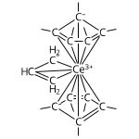 |  |  |  | 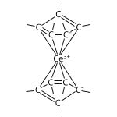

Synthesis and Comparative η1-Alkyl and Sterically Induced Reduction Reactivity of (C5Me5)3Ln Complexes of La, Ce, Pr, Nd, and Sm
By: Evans, William J.; et al
Organometallics (2005), 24(16), 3916-3931.
Find It @ Emory
10.1021/om050402l
View All Sources in CAS SciFinder

Steps: 1, Yield: 94%
CAS Reaction Number: 31-614-CAS-28703812
1.1 | Solvents: Benzene; 12 h, rt

10. Scheme 10 (1 Reaction)

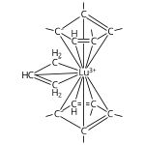 |  |  |  | 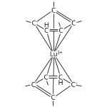

The Elusive (C5Me4H)3Lu: Its Synthesis and LnZ3/K/N2 Reactivity
By: Evans, William J.; et al
Organometallics (2005), 24(26), 6393-6397.
Find It @ Emory
10.1021/om050709k
View All Sources in CAS SciFinder

Steps: 1, Yield: 94%
CAS Reaction Number: 31-614-CAS-25954448
1.1 | Solvents: Benzene; 24 h, rt

11. Scheme 11 (1 Reaction)

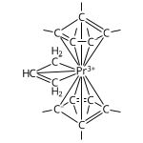 |  |  |  | 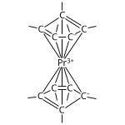

Synthesis and Comparative η1-Alkyl and Sterically Induced Reduction Reactivity of (C5Me5)3Ln Complexes of La, Ce, Pr, Nd, and Sm
By: Evans, William J.; et al
Organometallics (2005), 24(16), 3916-3931.
Find It @ Emory
10.1021/om050402l
View All Sources in CAS SciFinder

Steps: 1, Yield: 93%
CAS Reaction Number: 31-614-CAS-25258236
1.1 | Solvents: Benzene; rt

12. Scheme 12 (1 Reaction)

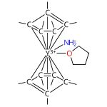 |  |  |  | 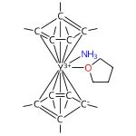

NH3 and (NH2)1- as ligands in yttrium metallocene chemistry
By: Boshart, Monica D.; et al
Dalton Transactions (2018), 47(14), 5098-5101.
Find It @ Emory
10.1039/c8dt00543e
View All Sources in CAS SciFinder

Steps: 1, Yield: 92%
CAS Reaction Number: 31-614-CAS-26978087
1.1 | Solvents: Tetrahydrofuran; 20 min, rt

13. Scheme 13 (1 Reaction)

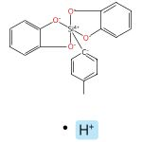 |  |  |  | 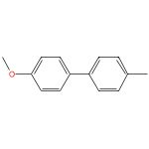

Preparation and Palladium-Catalyzed Cross-Coupling of Aryl Triethylammonium Bis(catechol) Silicates with Aryl Triflates
By: Seganish, W. Michael; et al
Journal of Organic Chemistry (2004), 69(4), 1137-1143.
Find It @ Emory
10.1021/jo035309q
View All Sources in CAS SciFinder

Steps: 1, Yield: 92%
CAS Reaction Number: 31-177-CAS-615217
1.1 | Reagents: Tetrabutylammonium fluoride
 | Catalysts: Bis(dibenzylideneacetone)palladium, 2-(Dicyclohexylphosphino)biphenyl
 | Solvents: Tetrahydrofuran; 6 h, reflux

14. Scheme 14 (1 Reaction)

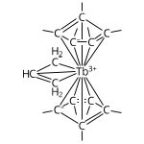 |  |  |  | 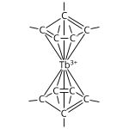

Exchange coupling and magnetic blocking in bipyrimidyl radical-bridged dilanthanide complexes
By: Demir, Selvan; et al
Journal of the American Chemical Society (2012), 134(45), 18546-18549.
Find It @ Emory
10.1021/ja308945d
View All Sources in CAS SciFinder

Steps: 1, Yield: 91%
CAS Reaction Number: 31-614-CAS-28717047
1.1 | Solvents: Toluene; overnight, rt

15. Scheme 15 (1 Reaction)

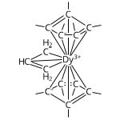 |  |  |  | 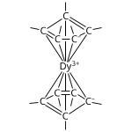

Exchange coupling and magnetic blocking in bipyrimidyl radical-bridged dilanthanide complexes
By: Demir, Selvan; et al
Journal of the American Chemical Society (2012), 134(45), 18546-18549.
Find It @ Emory
10.1021/ja308945d
View All Sources in CAS SciFinder

Steps: 1, Yield: 91%
CAS Reaction Number: 31-614-CAS-29838910
1.1 | Solvents: Toluene; overnight, rt

16. Scheme 16 (1 Reaction)

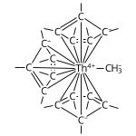 |  |  |  | 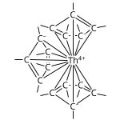

Synthesis, Structure, and Reactivity of the Sterically Crowded Th3+ Complex (C5Me5)3Th Including Formation of the Thorium Carbonyl, [(C5Me5)3Th(CO)][BPh4]
By: Langeslay, Ryan R.; et al
Journal of the American Chemical Society (2017), 139(9), 3387-3398.
Find It @ Emory
10.1021/jacs.6b10826
View All Sources in CAS SciFinder

Steps: 1, Yield: 90%
CAS Reaction Number: 31-614-CAS-31011773
1.1 | Solvents: Toluene; 15 h, rt

17. Scheme 17 (1 Reaction)

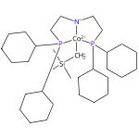 |  |  |  | 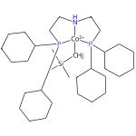  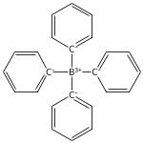

Understanding the mechanisms of cobalt-catalyzed hydrogenation and dehydrogenation reactions
By: Zhang, Guoqi; et al
Journal of the American Chemical Society (2013), 135(23), 8668-8681.
Find It @ Emory
10.1021/ja402679a
View All Sources in CAS SciFinder

Steps: 1, Yield: 90%
CAS Reaction Number: 31-614-CAS-27433373
1.1 | Solvents: Pentane, Tetrahydrofuran; 2 d, rt → -25 °C

18. Scheme 18 (1 Reaction)

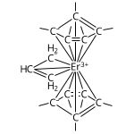 |  |  |  | 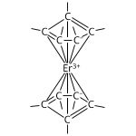

Tris(pentamethylcyclopentadienyl) Complexes of Late Lanthanides Tb, Dy, Ho, and Er: Solution and Mechanochemical Syntheses and Structural Comparisons
By: Woen, David H.; et al
Organometallics (2017), 36(23), 4558-4563.
Find It @ Emory
10.1021/acs.organomet.7b00385
View All Sources in CAS SciFinder

Steps: 1, Yield: 90%
CAS Reaction Number: 31-614-CAS-26723059
1.1 | Solvents: Toluene; 48 h, rt

19. Scheme 19 (1 Reaction)

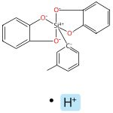 |  |  |  | 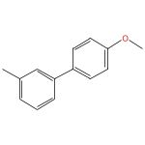

Preparation and Palladium-Catalyzed Cross-Coupling of Aryl Triethylammonium Bis(catechol) Silicates with Aryl Triflates
By: Seganish, W. Michael; et al
Journal of Organic Chemistry (2004), 69(4), 1137-1143.
Find It @ Emory
10.1021/jo035309q
View All Sources in CAS SciFinder

Steps: 1, Yield: 97%
CAS Reaction Number: 31-177-CAS-6518278
1.1 | Reagents: Tetrabutylammonium fluoride
 | Catalysts: Bis(dibenzylideneacetone)palladium, 2-(Dicyclohexylphosphino)biphenyl
 | Solvents: Tetrahydrofuran; 6 h, reflux

20. Scheme 20 (1 Reaction)

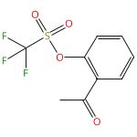 |  |  |  | 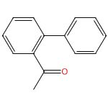

Preparation and Palladium-Catalyzed Cross-Coupling of Aryl Triethylammonium Bis(catechol) Silicates with Aryl Triflates
By: Seganish, W. Michael; et al
Journal of Organic Chemistry (2004), 69(4), 1137-1143.
Find It @ Emory
10.1021/jo035309q
View All Sources in CAS SciFinder

Steps: 1, Yield: 93%
CAS Reaction Number: 31-177-CAS-1119579
1.1 | Reagents: Tetrabutylammonium fluoride
 | Catalysts: Bis(dibenzylideneacetone)palladium, 2-(Dicyclohexylphosphino)biphenyl
 | Solvents: Tetrahydrofuran; 6 h, reflux

21. Scheme 21 (1 Reaction)

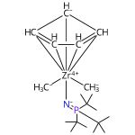 |  | 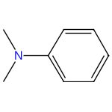 |  | 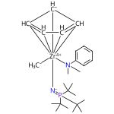  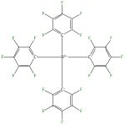

The Effects of Activators on Zirconium Phosphinimide Ethylene Polymerization Catalysts
By: Hollink, Emily; et al
Organometallics (2004), 23(7), 1562-1569.
Find It @ Emory
10.1021/om030631c
View All Sources in CAS SciFinder

Steps: 1, Yield: 100%
CAS Reaction Number: 31-203-CAS-11690525
1.1 | Solvents: Dichloromethane; 30 min, 25 °C

22. Scheme 22 (1 Reaction)

 |  | 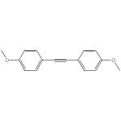 |  | 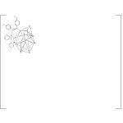

Couple-close construction of non-classical boron cluster-phosphonium conjugates
By: Sun, Zhaofeng; et al
Nature Communications (2024), 15(1), 7934.
Find It @ Emory
10.1038/s41467-024-51506-3
View All Sources in CAS SciFinder

Steps: 1, Yield: 90%
CAS Reaction Number: 31-614-CAS-41964299
1.1 | Catalysts: Palladium diacetate
 | Solvents: 1,2-Dichloroethane; 6 h, 35 °C

23. Scheme 23 (1 Reaction)

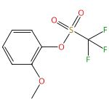 |  |  |  | 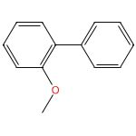

Preparation and Palladium-Catalyzed Cross-Coupling of Aryl Triethylammonium Bis(catechol) Silicates with Aryl Triflates
By: Seganish, W. Michael; et al
Journal of Organic Chemistry (2004), 69(4), 1137-1143.
Find It @ Emory
10.1021/jo035309q
View All Sources in CAS SciFinder

Steps: 1, Yield: 95%
CAS Reaction Number: 31-177-CAS-15310201
1.1 | Reagents: Tetrabutylammonium fluoride
 | Catalysts: Bis(dibenzylideneacetone)palladium, 2-(Dicyclohexylphosphino)biphenyl
 | Solvents: Tetrahydrofuran; 6 h, reflux

24. Scheme 24 (1 Reaction)

 |  | 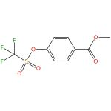 |  | 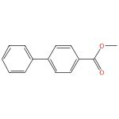

Preparation and Palladium-Catalyzed Cross-Coupling of Aryl Triethylammonium Bis(catechol) Silicates with Aryl Triflates
By: Seganish, W. Michael; et al
Journal of Organic Chemistry (2004), 69(4), 1137-1143.
Find It @ Emory
10.1021/jo035309q
View All Sources in CAS SciFinder

Steps: 1, Yield: 94%
CAS Reaction Number: 31-177-CAS-3223415
1.1 | Reagents: Tetrabutylammonium fluoride
 | Catalysts: Bis(dibenzylideneacetone)palladium, 2-(Dicyclohexylphosphino)biphenyl
 | Solvents: Tetrahydrofuran; 6 h, reflux

25. Scheme 25 (1 Reaction)

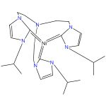 |  | 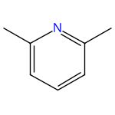 |  | 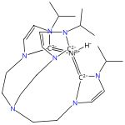  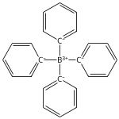

Closed Synthetic Cycle for Nickel-Based Dihydrogen Formation
By: Hosseinmardi, Soosan; et al
Chemistry - A European Journal (2023), 29(64), e202302063.
Find It @ Emory
10.1002/chem.202302063
View All Sources in CAS SciFinder

Steps: 1, Yield: 96%
CAS Reaction Number: 31-614-CAS-39889227
1.1 | Solvents: Tetrahydrofuran; 1 h, 0 °C

26. Scheme 26 (1 Reaction)

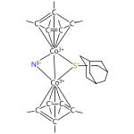 |  |  |  | 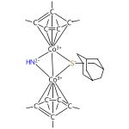

Unusual Hydrogenation Reactivities of a Thiolate-Bridged Dicobalt μ-Nitride Featuring a Bent { CoIII-N-CoIII} Core
By: Mei, Tao; et al
Journal of the American Chemical Society (2023), 145(37), 20578-20587.
Find It @ Emory
10.1021/jacs.3c07254
View All Sources in CAS SciFinder

Steps: 1, Yield: 90%
CAS Reaction Number: 31-614-CAS-38007513
1.1 | Solvents: Tetrahydrofuran; rt; 2 h, rt

27. Scheme 27 (1 Reaction)

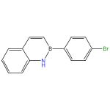 |  | 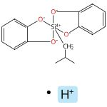 |  | 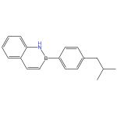

Accessing elaborated 2,1-borazaronaphthalene cores using photoredox/nickel dual-catalytic functionalization
By: Jouffroy, Matthieu; et al
Organic Letters (2016), 18(7), 1606-1609.
Find It @ Emory
10.1021/acs.orglett.6b00466
View All Sources in CAS SciFinder

Steps: 1, Yield: 94%
CAS Reaction Number: 31-614-CAS-27337043
1.1 | Catalysts: Dichloro[1,2-di(methoxy-κO)ethane]nickel, 4,4′-Bis(1,1-dimethylethyl)-2,2′-bipyridine
 | Solvents: Tetrahydrofuran
1.2 | Catalysts: Tris(2,2′-bipyridine)ruthenium(2+) bis(hexafluorophosphate)
 | Solvents: Dimethylformamide; 12 h, 30 °C

28. Scheme 28 (1 Reaction)

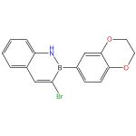 |  |  |  | 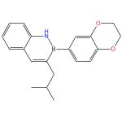

Accessing elaborated 2,1-borazaronaphthalene cores using photoredox/nickel dual-catalytic functionalization
By: Jouffroy, Matthieu; et al
Organic Letters (2016), 18(7), 1606-1609.
Find It @ Emory
10.1021/acs.orglett.6b00466
View All Sources in CAS SciFinder

Steps: 1, Yield: 94%
CAS Reaction Number: 31-614-CAS-29242377
1.1 | Catalysts: Dichloro[1,2-di(methoxy-κO)ethane]nickel, 4,4′-Bis(1,1-dimethylethyl)-2,2′-bipyridine
 | Solvents: Tetrahydrofuran
1.2 | Catalysts: Tris(2,2′-bipyridine)ruthenium(2+) bis(hexafluorophosphate)
 | Solvents: Dimethylformamide; 12 h, 30 °C

29. Scheme 29 (1 Reaction)

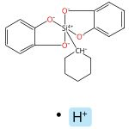  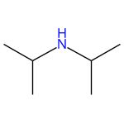 |  | 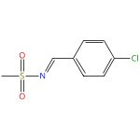 |  | 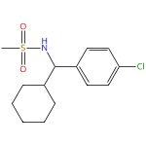

Mild, Redox-Neutral Alkylation of Imines Enabled by an Organic Photocatalyst
By: Patel, Niki R.; et al
ACS Catalysis (2017), 7(3), 1766-1770.
Find It @ Emory
10.1021/acscatal.6b03665
View All Sources in CAS SciFinder

Steps: 1, Yield: 90%
CAS Reaction Number: 31-614-CAS-24979911
1.1 | Catalysts: 2,4,5,6-Tetra(9H-carbazol-9-yl)isophthalonitrile
 | Solvents: Dimethyl sulfoxide; 24 h, 27 °C

30. Scheme 30 (1 Reaction)

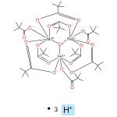 |  | 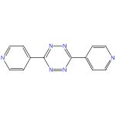 |  | 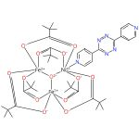

Electrochemical and Electrocatalytic Characteristics of Coordination Polymers Based on Trinuclear Pivalates and Heterocyclic Bridging Ligands
By: Lytvynenko, A. S.; et al
Theoretical and Experimental Chemistry (2015), 51(1), 54-61.
Find It @ Emory
10.1007/s11237-015-9397-7
View All Sources in CAS SciFinder

Steps: 1, Yield: 90%
CAS Reaction Number: 31-562-CAS-16202308
1.1 | Reagents: Pivalic acid
 | Solvents: Dimethylformamide, Acetonitrile; 24 h, 60 °C

31. Scheme 31 (1 Reaction)

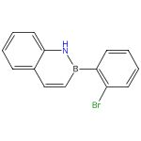 |  | 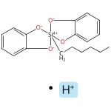 |  | 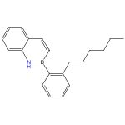

Accessing elaborated 2,1-borazaronaphthalene cores using photoredox/nickel dual-catalytic functionalization
By: Jouffroy, Matthieu; et al
Organic Letters (2016), 18(7), 1606-1609.
Find It @ Emory
10.1021/acs.orglett.6b00466
View All Sources in CAS SciFinder

Steps: 1, Yield: 97%
CAS Reaction Number: 31-614-CAS-25707154
1.1 | Catalysts: Dichloro[1,2-di(methoxy-κO)ethane]nickel, 4,4′-Bis(1,1-dimethylethyl)-2,2′-bipyridine
 | Solvents: Tetrahydrofuran
1.2 | Catalysts: Tris(2,2′-bipyridine)ruthenium(2+) bis(hexafluorophosphate)
 | Solvents: Dimethylformamide; 12 h, 30 °C

32. Scheme 32 (1 Reaction)

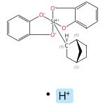  Relative stereochemistry shown |  |  |  | 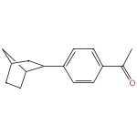

Phenol Derivatives as Coupling Partners with Alkylsilicates in Photoredox/Nickel Dual Catalysis
By: Patel, Niki R.; et al
Journal of Organic Chemistry (2016), 81(16), 7271-7275.
Find It @ Emory
10.1021/acs.joc.6b00800
View All Sources in CAS SciFinder

Steps: 1, Yield: 92%
CAS Reaction Number: 31-614-CAS-29588915
1.1 | Catalysts: Dichloro[1,2-di(methoxy-κO)ethane]nickel, 4,4′-Bis(1,1-dimethylethyl)-2,2′-bipyridine
 | Solvents: Tetrahydrofuran; heated
1.2 | Catalysts: Tris(2,2′-bipyridine)ruthenium(2+) bis(hexafluorophosphate)
 | Solvents: Dimethylformamide; 24 h, 27 °C

33. Scheme 33 (1 Reaction)

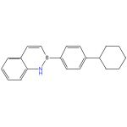

Accessing elaborated 2,1-borazaronaphthalene cores using photoredox/nickel dual-catalytic functionalization
By: Jouffroy, Matthieu; et al
Organic Letters (2016), 18(7), 1606-1609.
Find It @ Emory
10.1021/acs.orglett.6b00466
View All Sources in CAS SciFinder

Steps: 1, Yield: 97%
CAS Reaction Number: 31-614-CAS-29874509
1.1 | Catalysts: Dichloro[1,2-di(methoxy-κO)ethane]nickel, 4,4′-Bis(1,1-dimethylethyl)-2,2′-bipyridine
 | Solvents: Tetrahydrofuran
1.2 | Catalysts: Tris(2,2′-bipyridine)ruthenium(2+) bis(hexafluorophosphate)
 | Solvents: Dimethylformamide; 12 h, 30 °C

34. Scheme 34 (1 Reaction)

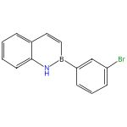 |  | Relative stereochemistry shown |  | 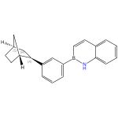  Relative stereochemistry shown

Accessing elaborated 2,1-borazaronaphthalene cores using photoredox/nickel dual-catalytic functionalization
By: Jouffroy, Matthieu; et al
Organic Letters (2016), 18(7), 1606-1609.
Find It @ Emory
10.1021/acs.orglett.6b00466
View All Sources in CAS SciFinder

Steps: 1, Yield: 96%
CAS Reaction Number: 31-614-CAS-26425944
1.1 | Catalysts: Dichloro[1,2-di(methoxy-κO)ethane]nickel, 4,4′-Bis(1,1-dimethylethyl)-2,2′-bipyridine
 | Solvents: Tetrahydrofuran
1.2 | Catalysts: Tris(2,2′-bipyridine)ruthenium(2+) bis(hexafluorophosphate)
 | Solvents: Dimethylformamide; 12 h, 30 °C

35. Scheme 35 (1 Reaction)

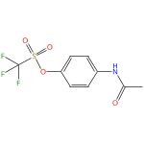 |  |  |  | 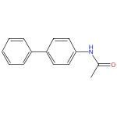

Preparation and Palladium-Catalyzed Cross-Coupling of Aryl Triethylammonium Bis(catechol) Silicates with Aryl Triflates
By: Seganish, W. Michael; et al
Journal of Organic Chemistry (2004), 69(4), 1137-1143.
Find It @ Emory
10.1021/jo035309q
View All Sources in CAS SciFinder

Steps: 1, Yield: 92%
CAS Reaction Number: 31-177-CAS-5367798
1.1 | Reagents: Tetrabutylammonium fluoride
 | Catalysts: Bis(dibenzylideneacetone)palladium, 2-(Dicyclohexylphosphino)biphenyl
 | Solvents: Tetrahydrofuran; 6 h, reflux

36. Scheme 36 (1 Reaction)

Relative stereochemistry shown |  | 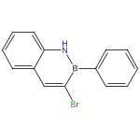 |  | 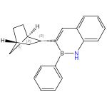  Relative stereochemistry shown

Accessing elaborated 2,1-borazaronaphthalene cores using photoredox/nickel dual-catalytic functionalization
By: Jouffroy, Matthieu; et al
Organic Letters (2016), 18(7), 1606-1609.
Find It @ Emory
10.1021/acs.orglett.6b00466
View All Sources in CAS SciFinder

Steps: 1, Yield: 96%
CAS Reaction Number: 31-614-CAS-25474120
1.1 | Catalysts: Dichloro[1,2-di(methoxy-κO)ethane]nickel, 4,4′-Bis(1,1-dimethylethyl)-2,2′-bipyridine
 | Solvents: Tetrahydrofuran
1.2 | Catalysts: Tris(2,2′-bipyridine)ruthenium(2+) bis(hexafluorophosphate)
 | Solvents: Dimethylformamide; 12 h, 30 °C

37. Scheme 37 (2 Reactions)

 |  | Relative stereochemistry shown |  | 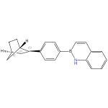  Relative stereochemistry shown

Accessing elaborated 2,1-borazaronaphthalene cores using photoredox/nickel dual-catalytic functionalization
By: Jouffroy, Matthieu; et al
Organic Letters (2016), 18(7), 1606-1609.
Find It @ Emory
10.1021/acs.orglett.6b00466
View All Sources in CAS SciFinder

Steps: 1, Yield: 96%
CAS Reaction Number: 31-614-CAS-29976760
1.1 | Catalysts: Dichloro[1,2-di(methoxy-κO)ethane]nickel, 4,4′-Bis(1,1-dimethylethyl)-2,2′-bipyridine
 | Solvents: Tetrahydrofuran
1.2 | Catalysts: Tris(2,2′-bipyridine)ruthenium(2+) bis(hexafluorophosphate)
 | Solvents: Dimethylformamide; 12 h, 30 °C

Accessing elaborated 2,1-borazaronaphthalene cores using photoredox/nickel dual-catalytic functionalization
By: Jouffroy, Matthieu; et al
Organic Letters (2016), 18(7), 1606-1609.
Find It @ Emory
10.1021/acs.orglett.6b00466
View All Sources in CAS SciFinder

Steps: 1, Yield: 96%
CAS Reaction Number: 31-614-CAS-30797211
1.1 | Catalysts: Dichloro[1,2-di(methoxy-κO)ethane]nickel, 4,4′-Bis(1,1-dimethylethyl)-2,2′-bipyridine
 | Solvents: Tetrahydrofuran
1.2 | Catalysts: Tris(2,2′-bipyridine)ruthenium(2+) bis(hexafluorophosphate)
 | Solvents: Dimethylformamide; 12 h, 30 °C

38. Scheme 38 (1 Reaction)

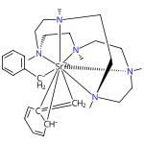  Relative stereochemistry shown |  | 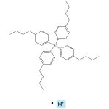 |  |   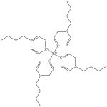

Strontium Hydride Cations Supported by a Large NNNNN Type Macrocycle: Synthesis, Structure, and Hydrofunctionalization Catalysis
By: Hoellerhage, Thomas; et al
Inorganic Chemistry (2022), 61(7), 3309-3316.
Find It @ Emory
10.1021/acs.inorgchem.1c03894
View All Sources in CAS SciFinder

Steps: 1, Yield: 90%
CAS Reaction Number: 31-614-CAS-31823864
1.1 | Solvents: Tetrahydrofuran; 5 min, rt

39. Scheme 39 (1 Reaction)

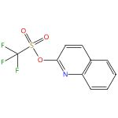 |  |  |  | 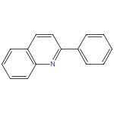

Preparation and Palladium-Catalyzed Cross-Coupling of Aryl Triethylammonium Bis(catechol) Silicates with Aryl Triflates
By: Seganish, W. Michael; et al
Journal of Organic Chemistry (2004), 69(4), 1137-1143.
Find It @ Emory
10.1021/jo035309q
View All Sources in CAS SciFinder

Steps: 1, Yield: 91%
CAS Reaction Number: 31-177-CAS-4696597
1.1 | Reagents: Tetrabutylammonium fluoride
 | Catalysts: Bis(dibenzylideneacetone)palladium, 2-(Dicyclohexylphosphino)biphenyl
 | Solvents: Tetrahydrofuran; 6 h, reflux

40. Scheme 40 (1 Reaction)

Relative stereochemistry shown |  | 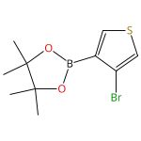 |  | 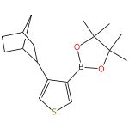

C(sp3)-C(sp2) cross-coupling of alkylsilicates with borylated aryl bromides - an iterative platform to alkylated aryl- and heteroaryl boronates
By: Vara, Brandon A.; et al
Chemical Science (2017), 8(1), 530-535.
Find It @ Emory
10.1039/c6sc03236b
View All Sources in CAS SciFinder

Steps: 1, Yield: 98%
CAS Reaction Number: 31-614-CAS-30944221
1.1 | Catalysts: Dichloro[1,2-di(methoxy-κO)ethane]nickel, 4,4′-Bis(1,1-dimethylethyl)-2,2′-bipyridine
 | Solvents: Tetrahydrofuran; heated; cooled
1.2 | Catalysts: 4,5,6-Tri-9H-carbazol-9-yl-2-(9H-fluoren-9-yl)-1,3-benzenedicarbonitrile
 | Solvents: Dimethylformamide; 14 h, 30 °C

41. Scheme 41 (1 Reaction)

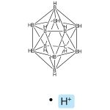 |  | 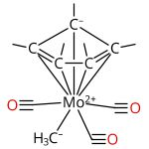 |  | 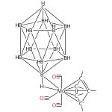

Synthesis and characterization of { Mo(η-L)(CO)3} + (η-L = C5H5 or C5Me5) fragments ligated with [CB11H12]- and derivatives. Isolation and structural characterization of an intermediate in a silver salt metathesis reaction
By: Patmore, Nathan J.; et al
Journal of the Chemical Society, Dalton Transactions (2001), (3), 277-283.
Find It @ Emory
10.1039/b008222h
View All Sources in CAS SciFinder

Steps: 1, Yield: 100%
CAS Reaction Number: 31-614-CAS-29014649
1.1 | Solvents: Dichloromethane

42. Scheme 42 (1 Reaction)

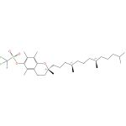  Absolute stereochemistry shown |  |  |  | 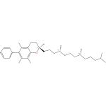  Absolute stereochemistry shown

Preparation and Palladium-Catalyzed Cross-Coupling of Aryl Triethylammonium Bis(catechol) Silicates with Aryl Triflates
By: Seganish, W. Michael; et al
Journal of Organic Chemistry (2004), 69(4), 1137-1143.
Find It @ Emory
10.1021/jo035309q
View All Sources in CAS SciFinder

Steps: 1, Yield: 90%
CAS Reaction Number: 31-177-CAS-228954
1.1 | Reagents: Tetrabutylammonium fluoride
 | Catalysts: Bis(dibenzylideneacetone)palladium, 2-(Dicyclohexylphosphino)biphenyl
 | Solvents: 1,4-Dioxane; 6 h, reflux

43. Scheme 43 (1 Reaction)

Relative stereochemistry shown |  | 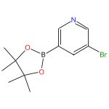 |  | 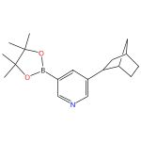

C(sp3)-C(sp2) cross-coupling of alkylsilicates with borylated aryl bromides - an iterative platform to alkylated aryl- and heteroaryl boronates
By: Vara, Brandon A.; et al
Chemical Science (2017), 8(1), 530-535.
Find It @ Emory
10.1039/c6sc03236b
View All Sources in CAS SciFinder

Steps: 1, Yield: 90%
CAS Reaction Number: 31-614-CAS-30841011
1.1 | Catalysts: Dichloro[1,2-di(methoxy-κO)ethane]nickel, 4,4′-Bis(1,1-dimethylethyl)-2,2′-bipyridine
 | Solvents: Tetrahydrofuran; heated; cooled
1.2 | Catalysts: 4,5,6-Tri-9H-carbazol-9-yl-2-(9H-fluoren-9-yl)-1,3-benzenedicarbonitrile
 | Solvents: Dimethylformamide; 16 h, 30 °C

44. Scheme 44 (1 Reaction)

 |  | 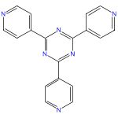 |  | 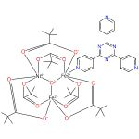

Heterometallic Coordination Polymers Assembled from Trigonal Trinuclear Fe2Ni-Pivalate Blocks and Polypyridine Spacers: Topological Diversity, Sorption, and Catalytic Properties
By: Sotnik, Svetlana A.; et al
Inorganic Chemistry (2015), 54(11), 5169-5181.
Find It @ Emory
10.1021/ic503061z
View All Sources in CAS SciFinder

Steps: 1, Yield: 95%
CAS Reaction Number: 31-562-CAS-13209836
1.1 | Reagents: Pivalic acid
 | Solvents: Dimethylformamide; rt; 1 h, 120 °C

45. Scheme 45 (1 Reaction)

Relative stereochemistry shown |  | 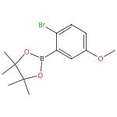 |  | 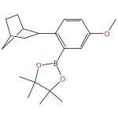

C(sp3)-C(sp2) cross-coupling of alkylsilicates with borylated aryl bromides - an iterative platform to alkylated aryl- and heteroaryl boronates
By: Vara, Brandon A.; et al
Chemical Science (2017), 8(1), 530-535.
Find It @ Emory
10.1039/c6sc03236b
View All Sources in CAS SciFinder

Steps: 1, Yield: 95%
CAS Reaction Number: 31-614-CAS-26695618
1.1 | Catalysts: Dichloro[1,2-di(methoxy-κO)ethane]nickel, 4,4′-Bis(1,1-dimethylethyl)-2,2′-bipyridine
 | Solvents: Tetrahydrofuran; heated; cooled
1.2 | Catalysts: 4,5,6-Tri-9H-carbazol-9-yl-2-(9H-fluoren-9-yl)-1,3-benzenedicarbonitrile
 | Solvents: Dimethylformamide; 7 h, 30 °C

46. Scheme 46 (1 Reaction)

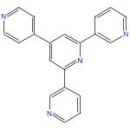 |  |  |  | 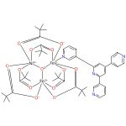

Heterometallic Coordination Polymers Assembled from Trigonal Trinuclear Fe2Ni-Pivalate Blocks and Polypyridine Spacers: Topological Diversity, Sorption, and Catalytic Properties
By: Sotnik, Svetlana A.; et al
Inorganic Chemistry (2015), 54(11), 5169-5181.
Find It @ Emory
10.1021/ic503061z
View All Sources in CAS SciFinder

Steps: 1, Yield: 95%
CAS Reaction Number: 31-562-CAS-1960506
1.1 | Reagents: Pivalic acid
 | Solvents: Dimethyl sulfoxide; rt; 1 h, 120 °C

47. Scheme 47 (1 Reaction)

 |  | 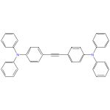 |  | 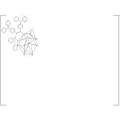

Couple-close construction of non-classical boron cluster-phosphonium conjugates
By: Sun, Zhaofeng; et al
Nature Communications (2024), 15(1), 7934.
Find It @ Emory
10.1038/s41467-024-51506-3
View All Sources in CAS SciFinder

Steps: 1, Yield: 92%
CAS Reaction Number: 31-614-CAS-41964305
1.1 | Catalysts: Palladium diacetate
 | Solvents: 1,2-Dichloroethane; 6 h, 35 °C

48. Scheme 48 (1 Reaction)

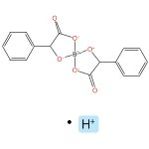  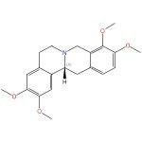  Absolute stereochemistry shown,  Rotation (+) |  | Absolute stereochemistry shown,  Rotation (+)

Bis(mandelato)borate: an effective, inexpensive spiroborate anion for chiral resolution
By: Wong, Lawrence W-Y.; et al
Chemical Communications (Cambridge, United Kingdom) (2015), 51(87), 15760-15763.
Find It @ Emory
10.1039/c5cc04977f
View All Sources in CAS SciFinder

Steps: 1, Yield: 90%
CAS Reaction Number: 31-575-CAS-2577471
1.1 | Reagents: Ammonium hydroxide
 | Solvents: Water; 1 h, rt

49. Scheme 49 (1 Reaction)

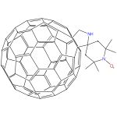  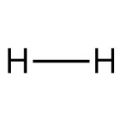 |  | 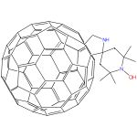  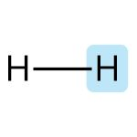

A Magnetic Switch for Spin-Catalyzed Interconversion of Nuclear Spin Isomers
By: Li, Yongjun; et al
Journal of the American Chemical Society (2010), 132(12), 4042-4043.
Find It @ Emory
10.1021/ja910282p
View All Sources in CAS SciFinder

Steps: 1, Yield: 95%
CAS Reaction Number: 31-491-CAS-18140416
1.1 | Reagents: Hydrazine, phenyl-
 | Solvents: Chloroform-d; 5 min, rt

50. Scheme 50 (1 Reaction)

A Magnetic Switch for Spin-Catalyzed Interconversion of Nuclear Spin Isomers
By: Li, Yongjun; et al
Journal of the American Chemical Society (2010), 132(12), 4042-4043.
Find It @ Emory
10.1021/ja910282p
View All Sources in CAS SciFinder

Steps: 1, Yield: 90%
CAS Reaction Number: 31-614-CAS-29126813
1.1 | Reagents: Cupric acetate
 | Solvents: Methanol, Chloroform-d; 10 min, rt

51. Scheme 51 (1 Reaction)

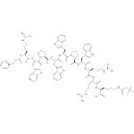  Absolute stereochemistry shown |  | 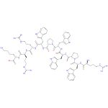  Absolute stereochemistry shown

Use of a TPB (tetraphenylborate) salt for the separation of biomolecules
Assignee: Solvay et Cie.
World Intellectual Property Organization, WO2009153294 A1 2009-12-23
Espacenet
View All Sources in CAS SciFinder

Steps: 1, Yield: 93%
CAS Reaction Number: 31-353-CAS-3821386
1.1 | Reagents: Hydrogen, Amberlite IRA 958
 | Catalysts: Palladium
 | Solvents: Methanol; 6 h, 35 ± 5 °C

Copyright © 2025 American Chemical Society (ACS). All Rights Reserved.

